**Implementation QA: Web Accessibility Test Plan**

**Full Recommendation, November 19, 2021**

**Authors:** [Diane Crawford](mailto:diane.crawford@radancy.com) & [Michael Spellacy](mailto:michael.spellacy@radancy.com)

**Summary** 2

**Objective** 2

**Testing Procedures** 3

**Automated Testing** 3

**Manual Testing** 4

**Introducing the A11y Smoke Test Extension** 4

**Baseline Issues** 5

**Non-Text Content** 5

**Captions (Prerecorded)** 6

**Information and Relationships** 7

**Use of Color** 8

**Contrast (Minimum)** 10

**Resize Text** 11

**Non-text Contrast** 12

**Keyboard** 14

**Pause, Stop, Hide & High Flash Rate** 15

**Three Flashes or Below Threshold** 15

**Bypass Blocks** 16

**Page Titled** 17

**Focus Order & Visibility** 17

**Parsing** 18

# **Summary**

Accessibility testing is the procedure that focuses on verifying usability and accessibility to accommodate people with disabilities, including visual, auditory, physical, speech, cognitive, language, learning, and neurological disabilities, who visit Radancy client websites.

For something to be accessible a person needs to be able to complete the task they are trying to achieve without encountering any barrier or issue. An experience that is equal to all users is also crucial. To complete a task on a website there are several things that need to work. The information that the user needs must be *perceivable* to them.

The Implementation QA (Quality Assurance) Team’s responsibility includes examination of Radancy client career and custom career websites, encompassing modules and features, that reside on site pages to ensure users with disabilities utilizing technologies such as screen magnification software, screen readers, speech recognition software, keyboards (assistive technology) to work and for communication, and more.

# **Objective**

The objective of accessibility testing is to ensure that functionality and content of Radancy client career and custom websites is in conformance with [Radancy Accessibility Testing Baselines](https://radancy.dev/a11y/baseline/). These are a subset of WCAG (Web Content and Accessibility Guidelines) 2.1 Level A and AA that speak to the most common barriers we have discovered on our sites.

Striving to meet these baselines does not mean we are in full compliance with WCAG but meeting them will improve the overall accessibility of our sites, while allowing our in-house accessibility specialists to focus on more robust testing needs.

The primary objective focuses on:

* Ensuring all areas of the website functions as expected to accommodate users with disabilities.
* Documentation of accessibility defects identified on the site and/or pages inclusive of modules during the examination of usability.

# **Testing Procedures**

Accessibility testing is performed in the preview environment on Radancy career sites and/or pages (content, engagement, self-service) at the completion of regression testing. The preview environment **must be stable**, i.e., no missing placeholder hero image(s), videos, video captions, video transcripts, hyperlinks, site pages, placeholder text, etc.

## **Automated Testing**

The first line of testing for accessibility issues is performed through automated means. Web accessibility evaluation tools are software programs or online services that assist us to determine if web content on a page meets accessibility standards.

## **Manual Testing**

Automated testing allows us to capture many programmatic accessibility issues but may only account for about 30% to 50% of all known accessibility issues a digital experience may face, so manual testing will be critical in helping Radancy deliver a more robust experience for all. While some of these can be addressed through automated testing means, many will need to be manually tested against.

## **Introducing A11y Pulse**

Radancy has developed a component to aid with automated and manual accessibility testing. This tool is meant to educate and inform and can run several in-page tests to help identify common accessibility issues against the baselines. In addition to this, the tool is also capable of sending the page you are testing through several online linting services, such as [WAVE](https://wave.webaim.org/) and the [W3C Validator](https://validator.w3.org/), whose results are captured and returned as a URL, which the QA engineer can then share in the documentation to be addressed by the UI (User Interface) developer.

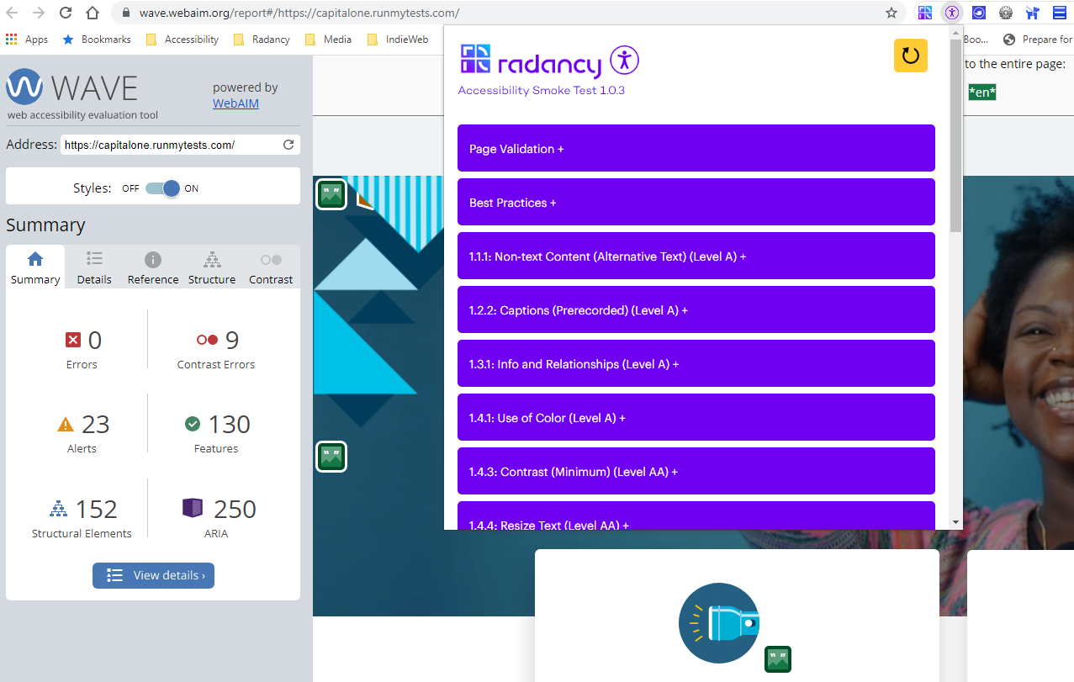

*Figure 1: Radancy’s A11y Smoke Test extension in action.*

To install, visit the [A11y Smoke Test](https://radancy.dev/a11y/extension/) extension page and choose your browser of choice. Before arriving on the page, you will be asked to log in:

**Username:** plugin-user

**Password:** Za94Z4C@!aDL

# **Baseline Issues**

## **Non-Text Content**

All site pages have buttons, hyperlinks, frames, images, videos, charts, maps, and other illustrative and interactive content.

Such content must be perceivable to all disabled users, particularly those who are blind or have low vision. Each non-text item must have an equivalent alternative text or accessible name that is identifiable to the user.   Although the WAVE tool can identify alternative text and accessible name values, it is the QA engineer’s responsibility to manually review the WAVE or A11y Smoke Test analysis of the site and recommend any additional alternative text or labeling deemed necessary.

* [Learn more about Non-Text Content (Images)](https://radancy.dev/a11y/baseline/#non-text-content-images)
* Learn more about Non-Text Content (Components & Multimedia)

## **Captions (Prerecorded)**

All video with audio dialogue must include captions.

Third-party services, such as YouTube, can create auto-captions, but these should not be fully relied upon to deliver an equal experience, so manual review of video to determine accuracy of captions will be required.

Any video with dialogue, whether self-hosted by Radancy or hosted on a third-party platform, that are found to have missing or inaccurate captions, must be reported as a defect.

Audio-only multimedia served with embedded audio players, such as a podcast or other presentation, must have transcripts available and should also be reported as a defect, if missing.

**Note:** Providing transcripts and audio descriptions with video is important and strongly encouraged, but not a failure if omitted at this time. Radancy intends to make these additional means of access a larger priority in future design and development work.

* [Learn more about Captions (Precorded)](https://radancy.dev/a11y/baseline/#captions-pre-recorded)

## **Information and Relationships**

Ensure that semantic markup is used appropriately. At this time, QA is only tasked with ensuring that headings (i.e., h1, h2) are present and that a proper hierarchy of content exists. However, some issues regarding page structure and semantics can be found by utilizing the W3C validator mentioned in Parsing.

A QA engineer can test the page to ensure that headings are present and structured logically by using the [A11y Smoke Test Extension](https://radancy.dev/a11y/extension/) (Validation Tools > Heading Validation). Missing or skipped headings should be reported as a defect. A screenshot of the heading structure can also be included in the log entry.

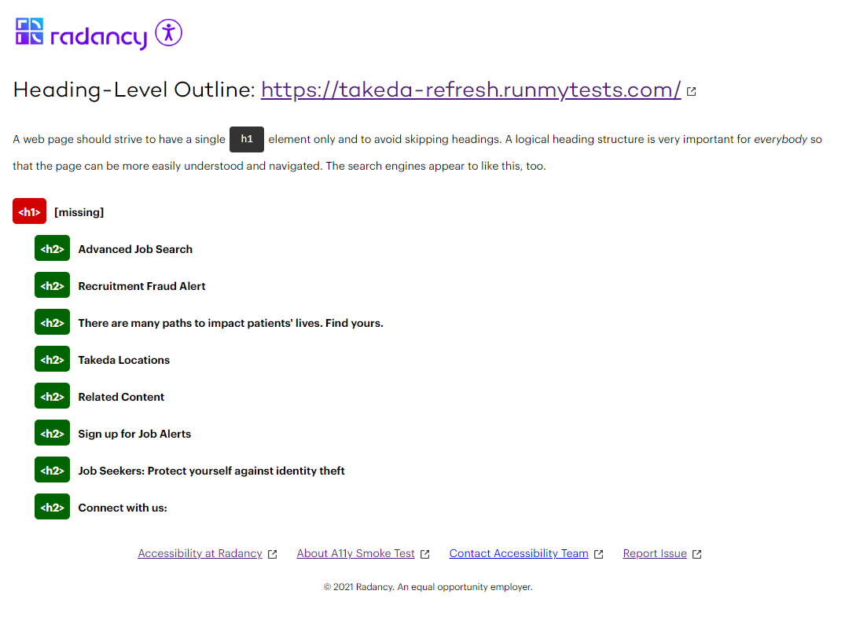

*Figure 2: Screenshot of Heading-Level Outline. Oh dear, the page is missing an h1 element.*

* [Learn more about Information & Relationships](https://radancy.dev/a11y/baseline/#info-and-relationships)

## **Use of Color**

Color should not be used as the sole means of conveying information to a user. For example, text that might say, “Correct all errors highlighted in red.” would be a failure because blind or low-vision users would be prevented from addressing any errors.

This guideline also applies to hyperlinks within the main content area of the page. Hyperlinks should be *distinguishable* from surrounding content and be flagged as a concern if they are not. Hyperlinks within the header and footer of a page are often understood to be links and can be excluded from this test.

For better usability, links should be underlined by default. Otherwise, link text must:

* Have a 3:1 contrast ratio with surrounding body text and must present a visual indicator (typically an underline) when hovering over or receiving focus.
* Both link and body text must have a 4.5:1 contrast ratio with the background (3:1 for large text).

Many contrast issues can be flagged in WAVE but the A11y Smoke Test Extension eyedropper tool can also test specific link, foreground, and background color values. The three colors will then be sent to WebAIM’s link contrast checker for analysis.

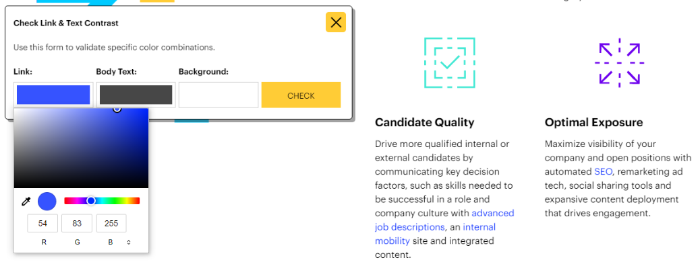

*Figure 3: Screenshot of Link Color Contrast picker in A11y Smoke Test. The results are sent to WebAIM’s Link & Text Color Contrast Checker*

* [Learn more about Use of Color](https://radancy.dev/a11y/baseline/#use-of-color)

## **Contrast (Minimum)**

Ensure that contrast between any foreground text and background color meets or exceeds a **4.5:1** color contrast ratio for regular sized text (WCAG 2.1 Level AA).

WAVE can be used to cite any potential contrast issues on the page being tested. If false positives are presented or you are not sure about certain colors being reported on, please reach out to the [accessibility team](mailto:a11y@radancy.com).

**Note:** Regarding text that may be present over background images, automated tools cannot accurately determine contrast in these scenarios, so it then becomes a judgment call on the part of the tester. Determining factors can include the luminosity of the background image as compared with the color and size of the foreground text, etc.

* [Learn more about Contrast (Minimum)](https://radancy.dev/a11y/baseline/#contrast-minimum)

## **Resize Text**

All web pages must be legible and functional at 200% page increase.  Use Control (PC) or Command (Mac) and + keys to increase zoom level of browser viewport. When 200% is reached, test to see if all page content can still be accessed and that the site continues to be fully operable.

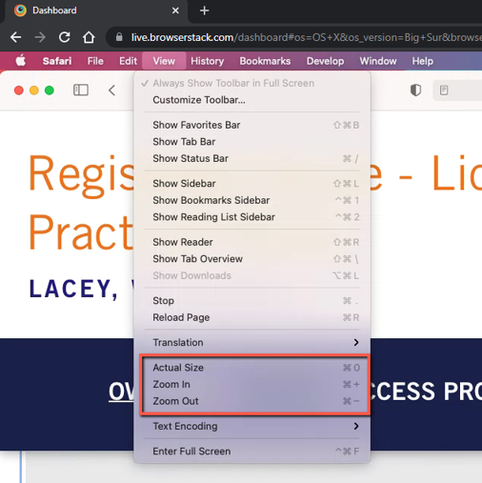

*Figure 5: Screenshot of zooming feature in Safari.*

* [Learn more about Resize Text](https://radancy.dev/a11y/baseline/#resize-text)

## **Non-text Contrast**

Ensure *important* visual components, such as images, icons, and buttons, have a contrast ratio of at least **3:1**.

WAVE can be used to cite any potential text-based contrast issues on the page being tested, but images and icons will need to be manually reviewed. If the graphic in question is deemed *informative* or *crucial* to functionality, then you can use the [A11y Smoke Test](https://radancy.dev/a11y/extension/) eyedropper tool (Validation Tools > Validate Contrast) to select any foreground and background colors from the graphic. The two colors will then be sent to WebAIM’s contrast checker for analysis. A contrast ratio that falls below 3:1 for *Graphical Objects and User Interface Components*, should be failed.

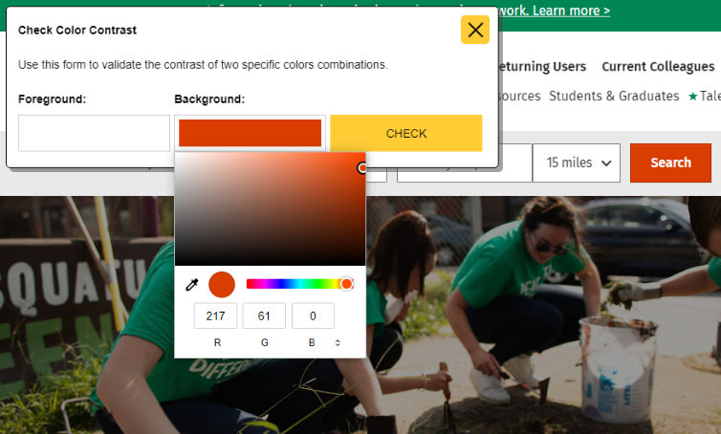

*Figure 4: Screenshot of Color Contrast color picker in A11y Smoke Test. The results are sent to WebAIM’s Color Contrast Checker*

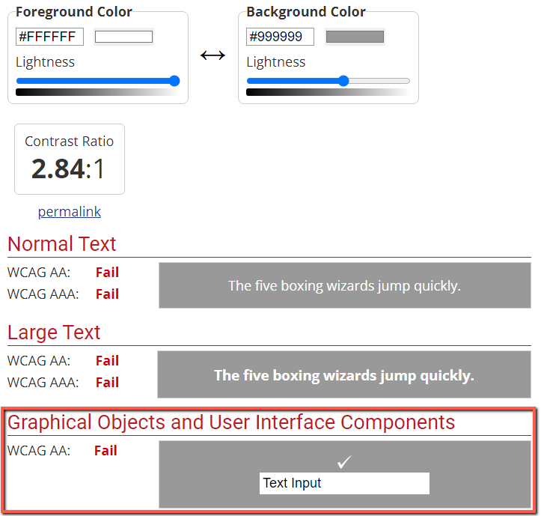

*Figure 5: Screenshot of contrast falling below 3:1 ratio threshold in WebAIM’s Contrast Checker.*

## **Keyboard**

Ensure that functionality within a web page is available using the keyboard only.  This is beneficial for users who are blind, have low vision (trouble finding or tracking a pointer or cursor) or have hand tremors.

While tabbing through a page, the QA engineer should manually test any interactive components that are available. Anything that can be used via other input modalities, such as a mouse or touch, must behave in a same or similar manner and be completely operable via keyboard alone. Accessing components on the page can be performed via the Enter or Spacebar key. In the case of buttons, users will expect both the Enter and Spacebar key to activate page functionality.

In some cases, keyboard focus may need to be manipulated (called focus management), but this is an advanced topic that will be covered later.

* [Learn more about Keyboard](https://radancy.dev/a11y/baseline/#keyboard)

## **Pause, Stop, Hide & High Flash Rate**

Automatic and *consistently* moving content such as that which is often found in auto-playing videos, carousels, scrolling interfaces or similar, are reviewed to ensure that a mechanism is present, such as a button, that can pause, stop, or hide any movement.  Any animation that fits this specific criterion should be cited as a failure.

* [Learn more about Pause, Stop, Hide](https://radancy.dev/a11y/baseline/#pause-stop-hide)

## **Three Flashes or Below Threshold**

Animations that are suspected of having a high strobing, flickering, or flashing effect (more than three flashes per second or below) are potentially dangerous for users who have photosensitive epilepsy and should be marked as a failure and *immediately* brought to the attention of [Michael Spellacy](mailto:michael.spellacy@radancy.com?subject=%22Animation%20Issue%22) or [Dan Green](mailto:dan.green@radancy.com).

* [Learn more about Three Flashes or Below Threshold](https://radancy.dev/a11y/baseline/#three-flashes-or-below)

## **Bypass Blocks**

Ensure that areas of a web page that require excessive tabbing, such as a navigation or a long list of hyperlinks, can be skipped over. This is often provided as a “skip link”. The purpose of a skip link is to make keyboard navigation easier and get users where they want to be quicker. The skip link should be visible to all when tabbed to and should, of course, be equally contrast friendly. The link should also indicate what position in the page it will take them to and not obscure other elements on the page, when visible. This last part may be difficult at times, but we should try our best.

Missing a skip link, particularly before the main navigation of a site, and not meeting the other criteria outlined here, should be marked as a failure.

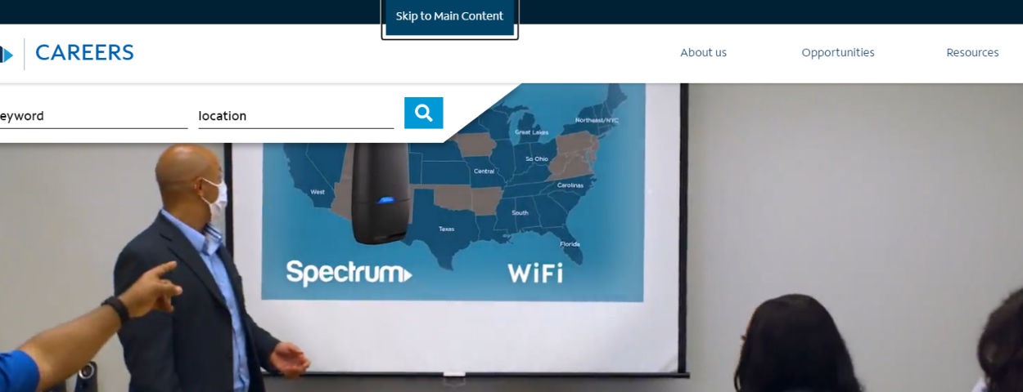

*Figure 6: The “skip link” as seen from Spectrum’s website (2021).*

* [More about Bypass Blocks](https://radancy.dev/a11y/baseline/#bypass-blocks)

## **Page Titled**

Each web page within the site includes a page title that is descriptive and allows users to identify what page they are using.  The QA engineer can view the page source and search for the title element or hover over the open tab (both standard in desktop browsers). The A11y Smoke Test extension can also display page titles.

* [Learn more about Page Titled](https://radancy.dev/a11y/baseline/#page-titles)

## **Focus Order & Visibility**

Ensure that keyboard focus follows a linear order while tabbing and that focus is identifiable. Focus should generally follow the visual flow of the page (top to bottom, left to right on English sites), beginning in the header and ending in the footer.

The QA engineer performs a tab key navigation test on the page by placing the cursor in the browser’s address bar, then repeatedly presses the tab key while observing the cursor’s movement through elements on the page, which may include links, buttons, form fields, etc. If the focus order does not follow a somewhat linear path, vanishes while tabbing, or does not include an adequate focus state, such as an outline, then this is a failure.

* [Learn more about Focus Order](https://radancy.dev/a11y/baseline/#focus-order)
* [Learn more about Focus Visibility](https://radancy.dev/a11y/baseline/#focus-visible)